**Student Information System (SIS)**

-- Task 1. Database Design:

-- 1. Create the database named "SISDB"

CREATE DATABASE SISDB;

-- Use the database named SISDB

USE SISDB;

/* 2. Define the schema for the Students, Courses, Enrollments, Teacher, and Payments tables based

on the provided schema. Write SQL scripts to create the mentioned tables with appropriate data

types, constraints, and relationships.

a. Students

b. Courses

c. Enrollments

d. Teacher

e. Payments*/

-- table creation

CREATE TABLE Teacher (

teacher_id INT PRIMARY KEY AUTO_INCREMENT,

first_name VARCHAR(50),

last_name VARCHAR(50),

email VARCHAR(100) UNIQUE

);

-- desc Teacher;

CREATE TABLE Students (

student_id INT PRIMARY KEY AUTO_INCREMENT,

first_name VARCHAR(50),

last_name VARCHAR(50),

date_of_birth DATE,

email VARCHAR(100) UNIQUE,

phone_number VARCHAR(20)

);

-- desc students;

CREATE TABLE Courses (

course_id INT PRIMARY KEY AUTO_INCREMENT,

course_name VARCHAR(100),

credits INT,

teacher_id INT,

FOREIGN KEY (teacher_id) REFERENCES Teacher(teacher_id) ON DELETE CASCADE

);

CREATE TABLE Enrollments (

enrollment_id INT PRIMARY KEY ,

student_id INT,

course_id INT,

enrollment_date DATE,

FOREIGN KEY (student_id) REFERENCES Students(student_id) ON DELETE CASCADE,

FOREIGN KEY (course_id) REFERENCES Courses(course_id)

);

CREATE TABLE Payments (

payment_id INT PRIMARY KEY,

student_id INT,

amount DECIMAL(10, 2),

payment_date DATE,

FOREIGN KEY (student_id) REFERENCES Students(student_id) ON DELETE CASCADE

);

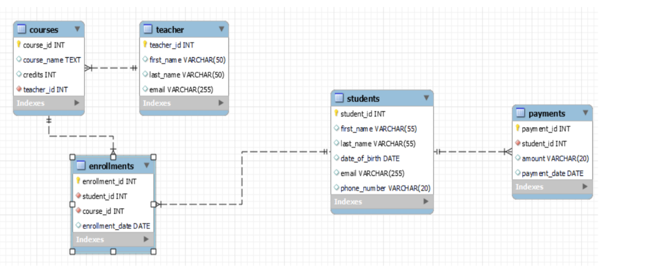

-- 3. Create an ERD (Entity Relationship Diagram) for the database

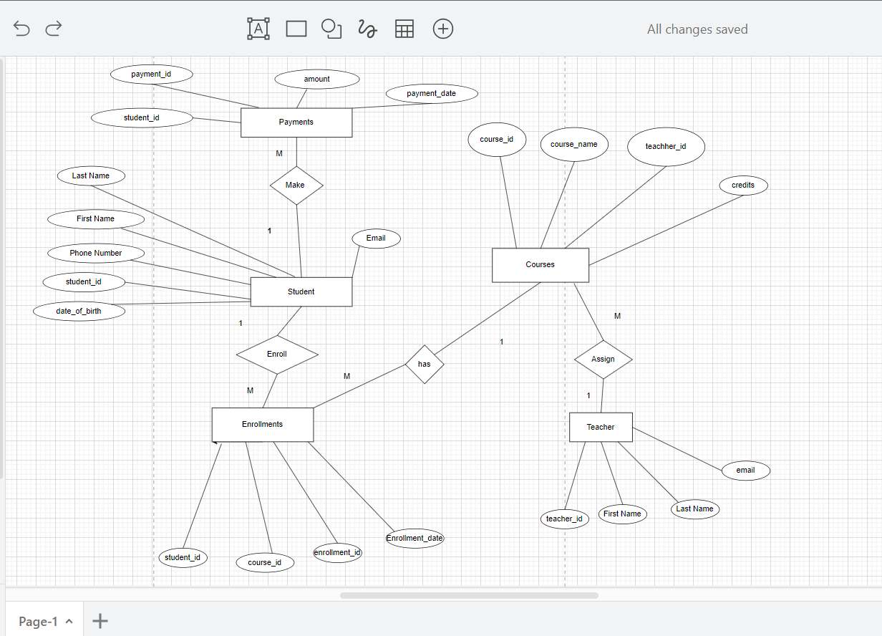

/* 5. Insert at least 10 sample records into each of the following tables.

i. Students

ii. Courses

iii. Enrollments

iv. Teacher

v. Payments */

-- values insertion

INSERT INTO Students (student_id, first_name, last_name, date_of_birth, email, phone_number)

VALUES

(301, 'Anurag', 'Kumar', '1995-03-20', 'anurag.kumar@example.com', '9876543210'),

(302, 'ankit', 'roy', '1998-07-12', 'ankit.roy@example.com', '8765432109'),

(303, 'Anil', 'Sharma', '1997-05-15', 'anil.sharma@example.com', '7654321098'),

(304, 'gopi', 'reddy', '1996-12-02', 'gopi.reddy@example.com', '6543210987'),

(305, 'Rohan', 'Verma', '1999-08-25', 'rohan.verma@example.com', '5432109876'),

(306, 'Neha', 'Gupta', '1994-10-08', 'neha.gupta@example.com', '4321098765'),

(307, 'Vivan', 'Rajput', '1993-06-30', 'vivan.rajput@example.com', '3210987654'),

(308, 'Avani', 'Reddy', '1992-04-12', 'avani.reddy@example.com', '2109876543'),

(309, 'Aryan', 'Malhotra', '1991-02-18', 'aryan.malhotra@example.com', '1098765432'),

(310, 'Sanya', 'Thakur', '1990-11-05', 'sanya.thakur@example.com', '9876543210'),

(311, 'Aisha', 'Malik', '1994-09-18', 'aisha.malik@example.com', '9876543210'),

(312, 'Rahul', 'Sharma', '1996-05-12', 'rahul.sharma@example.com', '8765432109'),

(313, 'Sara', 'Khan', '1998-03-25', 'sara.khan@example.com', '7654321098'),

(314, 'Aditya', 'Verma', '1997-11-02', 'aditya.verma@example.com', '6543210987'),

(315, 'Neha', 'Singh', '1995-08-25', 'neha.singh@example.com', '5432109876');

INSERT INTO Teacher (teacher_id, first_name, last_name, email)

VALUES

(101, 'Professor', 'Brown', 'prof.brown@example.com'),

(102, 'Dr.', 'Taylor', 'dr.taylor@example.com'),

(103, 'Ms.', 'Clark', 'ms.clark@example.com'),

(104, 'Mr.', 'Lee', 'mr.lee@example.com'),

(105, 'Mrs.', 'Adams', 'mrs.adams@example.com'),

(106, 'Dr.', 'Garcia', 'dr.garcia@example.com'),

(107, 'Mrs.', 'Martin', 'mrs.martin@example.com'),

(108, 'Mr.', 'Roberts', 'mr.roberts@example.com'),

(109, 'Professor', 'Wang', 'prof.wang@example.com'),

(110, 'Dr.', 'Lopez', 'dr.lopez@example.com'),

(111, 'Prof.', 'Smith', 'prof.smith@example.com'),

(312, 'Dr.', 'Anderson', 'dr.anderson@example.com'),

(313, 'Ms.', 'Johnson', 'ms.johnson@example.com');

INSERT INTO Courses (course_id, course_name, credits, teacher_id)

VALUES

(401, 'Math', 4, 101),

(402, 'Economics', 3, 102),

(403, 'Mathematics', 3, 103),

(404, 'philosphy', 4, 104),

(405, 'History', 3, 105),

(406, 'Computer Science', 4, 106),

(407, 'Biology', 4, 107),

(408, 'Chemistry', 3, 108),

(409, 'Geography', 3, 109),

(410, 'civics', 4, 110),

(411, 'Psychology', 3, 101),

(412, 'Sociology', 3, 102),

(413, 'Philosophy', 4, 103),

(414, 'Statistics', 3, 104),

(415, 'Political Science', 4, 105),

(421, 'Psychology', 3, 101),

(422, 'Sociology', 3, 102),

(423, 'Philosophy', 4, 103),

(424, 'Statistics', 3, 104),

(425, 'Political Science', 4, 105);

INSERT INTO Enrollments (enrollment_id, student_id, course_id, enrollment_date)

VALUES

(501, 301, 401, '2023-01-05'),

(502, 301, 402, '2023-02-10'),

(503, 302, 410, '2023-01-15'),

(504, 303, 403, '2023-03-01'),

(505, 304, 404, '2023-02-20'),

(506, 305, 405, '2023-01-10'),

(507, 306, 406, '2023-01-05'),

(508, 307, 407, '2023-02-15'),

(509, 308, 408, '2023-02-25'),

(510, 309, 409, '2023-03-05'),

(521, 311, 411, '2023-03-15'),

(522, 311, 412, '2023-03-20'),

(523, 312, 413, '2023-04-01'),

(524, 312, 414, '2023-04-10'),

(525, 313, 415, '2023-04-15'),

(526, 313, 401, '2023-05-01'),

(527, 314, 402, '2023-05-10'),

(528, 314, 403, '2023-05-20'),

(529, 315, 404, '2023-06-01'),

(530, 315, 405, '2023-06-10');

INSERT INTO Enrollments (enrollment_id, student_id, course_id, enrollment_date)

VALUES

(536, 303, 401, '2023-06-20'),

(537, 303, 402, '2023-07-05'),

(538, 303, 403, '2023-07-15'),

(539, 303, 404, '2023-08-01'),

(540, 303, 405, '2023-08-10'),

(541, 303, 406, '2023-08-20'),

(542, 303, 407, '2023-09-05'),

(543, 303, 408, '2023-09-15'),

(544, 303, 409, '2023-10-01'),

(545, 303, 410, '2023-10-10'),

(546, 303, 411, '2023-10-20'),

(547, 303, 412, '2023-11-05'),

(548, 303, 413, '2023-11-10'),

(549, 303, 414, '2023-11-20'),

(550, 303, 415, '2023-12-05'),

(551, 303, 421, '2023-12-10'),

(552, 303, 422, '2023-12-20'),

(553, 303, 423, '2024-01-05'),

(554, 303, 424, '2024-01-10'),

(555, 303, 425, '2024-01-20'),

(556,303,440,'2024-01-10');

INSERT INTO Payments (payment_id, student_id, amount, payment_date)

VALUES

(601, 301, 180.00, '2023-01-10'),

(602, 302, 160.50, '2023-02-15'),

(603, 303, 190.00, '2023-03-01'),

(604, 304, 175.00, '2023-02-20'),

(605, 305, 100.00, '2023-01-15'),

(606, 306, 120.00, '2023-03-05'),

(607, 307, 95.50, '2023-02-10'),

(608, 308, 85.00, '2023-01-20'),

(609, 309, 110.00, '2023-02-25'),

(610, 310, 70.00, '2023-01-05');

-- Cheching All Tables

-- select * from courses;

-- select * from enrollments;

-- select * from payments;

-- select * from students;

-- select * from teacher;

**-- Tasks 2: Select, Where, Between, AND, LIKE:**

/* 1. Write an SQL query to insert a new student into the "Students" table with the following details:

a. First Name: John

b. Last Name: Doe

c. Date of Birth: 1995-08-15

d. Email: john.doe@example.com

e. Phone Number: 1234567890*/

INSERT INTO Students(first_name,last_name,date_of_birth,email,phone_number)VALUES ('John','Doe','1995-08-15','john.doe@example.com',' 1234567890');

/* 2. Write an SQL query to enroll a student in a course.

Choose an existing student and course and insert a record into the "Enrollments" table with the enrollment date*/

INSERT INTO Enrollments (enrollment_id, student_id, course_id, enrollment_date)

VALUES (512, 301, 401, '2023-12-01');

INSERT INTO Enrollments (enrollment_id, student_id, course_id, enrollment_date)

VALUES (531, 301, 401, '2023-12-06');

INSERT INTO Enrollments (enrollment_id, student_id, course_id, enrollment_date)

VALUES (517, 301, 401, '2023-12-08');

INSERT INTO Enrollments (enrollment_id, student_id, course_id, enrollment_date)

VALUES (518, 306, 401, '2023-12-05');

-- FOR CHECKING INSERTED VALUE USE

-- select * from enrollments;

/* 3. Update the email address of a specific teacher in the "Teacher" table. Choose any teacher and

modify their email address.*/

UPDATE Teacher SET email = 'mew@gmailcom' WHERE teacher_id = 107;

-- FOR CHECKING UPDATED VALUE USE

-- select * from teacher;

/* 4.Write an SQL query to delete a specific enrollment record from the "Enrollments" table. Select

an enrollment record based on the student and course.*/

DELETE FROM Enrollments

WHERE student_id = 301 AND course_id = 401;

/* 5. Update the "Courses" table to assign a specific teacher to a course. Choose any course and

teacher from the respective tables.*/

UPDATE Courses

SET teacher_id = 101

WHERE course_id = 402;

-- 6. Delete a specific student from the "Students" table and remove all their enrollment records

-- from the "Enrollments" table. Be sure to maintain referential integrity.

DELETE FROM Students

WHERE student_id = 302;

-- FOR CHECKING UPDATED VALUE USE

-- select * from Students;

-- 7. Update the payment amount for a specific payment record in the "Payments" table. Choose any

-- payment record and modify the payment amount.

UPDATE Payments

SET amount = 120.00

WHERE payment_id = 602;

-- FOR CHECKING UPDATED VALUE USE

-- select * from payments;

**-- Task 3. Aggregate functions, Having, Order By, GroupBy and Joins:**

/* 1. Write an SQL query to calculate the total payments made by a specific student. You will need to

join the "Payments" table with the "Students" table based on the student's ID.*/

SELECT s.student_id, CONCAT(s.first_name,' ',s.last_name) AS FULL_NAME, SUM(p.amount) AS total_payments

FROM Students s

JOIN Payments p ON s.student_id = p.student_id

WHERE s.student_id = 305

GROUP BY s.student_id;

/* 2. Write an SQL query to retrieve a list of courses along with the count of students enrolled in each

course. Use a JOIN operation between the "Courses" table and the "Enrollments" table.*/

SELECT c.course_id, c.course_name, COUNT(e.student_id) AS enrolled_students

FROM Courses c

LEFT JOIN Enrollments e ON c.course_id = e.course_id

GROUP BY c.course_id, c.course_name;

/* 3. Write an SQL query to find the names of students who have not enrolled in any course. Use a

LEFT JOIN between the "Students" table and the "Enrollments" table to identify students

without enrollments.*/

SELECT CONCAT(s.first_name,' ', s.last_name) AS Full_Name

FROM Students s

LEFT JOIN Enrollments e ON s.student_id = e.student_id

WHERE e.student_id IS NULL;

/*.4. . Write an SQL query to retrieve the first name, last name of students, and the names of the

courses they are enrolled in. Use JOIN operations between the "Students" table and the

"Enrollments" and "Courses" tables.*/

SELECT s.first_name, s.last_name, c.course_name

FROM Students s

JOIN Enrollments e ON s.student_id = e.student_id

JOIN Courses c ON e.course_id = c.course_id;

/*. 5. Create a query to list the names of teachers and the courses they are assigned to. Join the

"Teacher" table with the "Courses" table.*/

SELECT CONCAT(t.first_name,' ', t.last_name) AS NAME_OF_TEACHER, c.course_name

FROM Teacher t

JOIN Courses c ON t.teacher_id = c.teacher_id;

/* .6. Retrieve a list of students and their enrollment dates for a specific course. You'll need to join the

"Students" table with the "Enrollments" and "Courses" tables.*/

SELECT CONCAT(s.first_name,' ',s.last_name) FULL_NAME , e.enrollment_date,e.course_id

FROM Students s

JOIN Enrollments e ON s.student_id = e.student_id

WHERE e.course_id = 403;

/* .7. . Find the names of students who have not made any payments. Use a LEFT JOIN between the

"Students" table and the "Payments" table and filter for students with NULL payment records*/

SELECT CONCAT(s.first_name,' ', s.last_name) AS FULL_NAME

FROM Students s

LEFT JOIN Payments p ON s.student_id = p.student_id

WHERE p.payment_id IS NULL;

/* .8. . Write a query to identify courses that have no enrollments. You'll need to use a LEFT JOIN

between the "Courses" table and the "Enrollments" table and filter for courses with NULL

enrollment records*/

SELECT c.course_id, c.course_name

FROM Courses c

LEFT JOIN Enrollments e ON c.course_id = e.course_id

WHERE e.enrollment_id IS NULL;

/* .9. Identify students who are enrolled in more than one course. Use a self-join on the "Enrollments"

table to find students with multiple enrollment records.*/

SELECT e1.student_id, CONCAT(s.first_name,' ',s.last_name) AS FULL_NAME, COUNT(DISTINCT e1.course_id) AS courses_enrolled

FROM Enrollments e1

JOIN Enrollments e2 ON e1.student_id = e2.student_id AND e1.enrollment_id <> e2.enrollment_id

JOIN Students s on s.student_id=e1.student_id

GROUP BY e1.student_id

HAVING COUNT(DISTINCT e1.course_id) > 1;

/* 10. 0. Find teachers who are not assigned to any courses. Use a LEFT JOIN between the "Teacher"

table and the "Courses" table and filter for teachers with NULL course assignments.*/

SELECT CONCAT(t.first_name,' ', t.last_name) AS NAME_OF_TEACHER

FROM Teacher t

LEFT JOIN Courses c ON t.teacher_id = c.teacher_id

WHERE c.course_id IS NULL;

**-- Task 4. Subquery and its type:**

/* .1. . Write an SQL query to calculate the average number of students enrolled in each course. Use

aggregate functions and subqueries to achieve this.*/

SELECT c.course_id, c.course_name,

AVG(enrollment_count) AS average_students_enrolled

FROM Courses c LEFT JOIN ( SELECT course_id,COUNT(DISTINCT student_id) AS enrollment_count

FROM Enrollments GROUP BY course_id) e ON c.course_id = e.course_id

GROUP BY c.course_id, c.course_name;

/* .2. Identify the student(s) who made the highest payment. Use a subquery to find the maximum

payment amount and then retrieve the student(s) associated with that amount. */

SELECT CONCAT(s.first_name,s.last_name) AS Full_Name, a.amt FROM students s JOIN (

SELECT student_id,sum(amount) amt FROM Payments

GROUP BY student_id

ORDER BY amt DESC LIMIT 1) a ON s.student_id=a.student_id ;

-- CHECKING THE ENTRY

-- select * from payments;

-- select * from courses;

/* .3. Retrieve a list of courses with the highest number of enrollments. Use subqueries to find the

course(s) with the maximum enrollment count.*/

SELECT c.course_id, c.course_name, count(e.enrollment_id) AS en_count

FROM Courses c LEFT JOIN Enrollments e ON c.course_id = e.course_id GROUP BY c.course_id, c.course_name

HAVING en_count = (SELECT max(en_count) FROM (SELECT count(enrollment_id) AS en_count FROM Enrollments

GROUP BY course_id) AS maximum_enrolls);

/* 4. Calculate the total payments made to courses taught by each teacher. Use subqueries to sum

payments for each teacher's courses.*/

SELECT t.teacher_id,c.course_id,c.course_name,CONCAT(t.first_name ,' ',t.last_name )AS NAME_OF_TEACHER ,SUM(p.amount) AS total_payments_IN$

FROM Teacher t LEFT JOIN Courses c ON t.teacher_id = c.teacher_id

LEFT JOIN Enrollments e ON c.course_id = e.course_id LEFT JOIN Payments p ON e.student_id = p.student_id

GROUP BY c.course_id,t.teacher_id;

/* .5. Identify students who are enrolled in all available courses. Use subqueries to compare a

student's enrollments with the total number of courses*/

-- adding data so that 303 is enrolled in all the courses

INSERT INTO Enrollments (enrollment_id, student_id, course_id, enrollment_date)

VALUES

(536, 303, 401, '2023-06-20'),

(537, 303, 402, '2023-07-05'),

(538, 303, 403, '2023-07-15'),

(539, 303, 404, '2023-08-01'),

(540, 303, 405, '2023-08-10'),

(541, 303, 406, '2023-08-20'),

(542, 303, 407, '2023-09-05'),

(543, 303, 408, '2023-09-15'),

(544, 303, 409, '2023-10-01'),

(545, 303, 410, '2023-10-10'),

(546, 303, 411, '2023-10-20'),

(547, 303, 412, '2023-11-05'),

(548, 303, 413, '2023-11-10'),

(549, 303, 414, '2023-11-20'),

(550, 303, 415, '2023-12-05'),

(551, 303, 421, '2023-12-10'),

(552, 303, 422, '2023-12-20'),

(553, 303, 423, '2024-01-05'),

(554, 303, 424, '2024-01-10'),

(555, 303, 425, '2024-01-20'),

(556,303,440,'2024-01-10'),

(557,303,449,'2024-01-05');

SELECT e.student_id ,CONCAT(s.first_name,' ',s.last_name) AS Full_Name FROM Enrollments e

JOIN Students s ON e.student_id=s.student_id

GROUP BY e.student_id

HAVING count( DISTINCT course_id) = (SELECT COUNT(DISTINCT course_id) FROM Courses);

/* .6. Retrieve the names of teachers who have not been assigned to any courses. Use subqueries to

find teachers with no course assignments.*/

select teacher_id, CONCAT(first_name,' ' ,last_name) AS NAME_OF_TEACHER from Teacher where teacher_id not in (select distinct teacher_id from Courses);

/* .7. Calculate the average age of all students. Use subqueries to calculate the age of each student

based on their date of birth.*/

SELECT AVG(student_age) AS average_age

FROM (SELECT DATEDIFF(CURDATE(), date_of_birth) / 365 AS student_age FROM Students) AS avg_ages;

/* .8. Identify courses with no enrollments. Use subqueries to find courses without enrollment

records*/

-- adding a course which has no enrollments

INSERT INTO Courses (course_id, course_name, credits, teacher_id)

VALUES

(459, 'ML', 9, 102);

-- (450, 'sql',30,102);

SELECT course_id, course_name FROM Courses WHERE course_id NOT IN (SELECT DISTINCT course_id FROM Enrollments);

/*9. Calculate the total payments made by each student for each course they are enrolled in. Use

subqueries and aggregate functions to sum payments.*/

SELECT e.student_id,concat(s.first_name,' ',s.last_name) AS FULL_NAME ,e.course_id,(SELECT sum(amount) FROM payments p

WHERE p.student_id = e.student_id) AS total_payments

FROM enrollments e

JOIN Students s on s.student_id=e.student_id

GROUP BY e.student_id,e.course_id;

-- select * from payments

/* 10. Identify students who have made more than one payment. Use subqueries and aggregate

functions to count payments per student and filter for those with counts greater than one.*/

SELECT s.student_id, CONCAT(s.first_name, '',s.last_name) AS Full_Name FROM students s

JOIN ( SELECT student_id, COUNT(payment_id) AS payment_count FROM payments GROUP BY student_id)

AS payment_counts ON s.student_id = payment_counts.student_id

WHERE payment_counts.payment_count > 1;

/* 11. Write an SQL query to calculate the total payments made by each student. Join the "Students"

table with the "Payments" table and use GROUP BY to calculate the sum of payments for each

student.*/

SELECT s.student_id, CONCAT(s.first_name,' ', s.last_name) AS FULL_NAME, SUM(p.amount) AS total_payments FROM Students s

JOIN Payments p ON s.student_id = p.student_id GROUP BY s.student_id;

/* 12. Retrieve a list of course names along with the count of students enrolled in each course. Use

JOIN operations between the "Courses" table and the "Enrollments" table and GROUP BY to

count enrollments*/

-- IN QUESTION IT IS MENTIONED TO USE JOIN

SELECT c.course_name, count(e.enrollment_id) AS students_enrolled FROM Courses c

LEFT JOIN Enrollments e ON c.course_id = e.course_id GROUP BY c.course_id;

/* 13. Calculate the average payment amount made by students. Use JOIN operations between the

"Students" table and the "Payments" table and GROUP BY to calculate the average.*/

SELECT s.student_id, CONCAT(s.first_name, ' ',s.last_name) AS FULL_NAME, AVG(p.amount) AS average_payment_amount from Students s

JOIN Payments p ON s.student_id = p.student_id GROUP BY s.student_id;